1 Introduction 3
1.1 Purpose and Scope 3
2 Test Design Overview 3
2.1.1 TEF functionality 4
3 Detailed Design 6
3.1 ContactUtilitiesCollection 6
3.1.1 Overview 6
3.1.2 UML Diagram 8
3.2 CTestContactViewConstructionStep 9
3.2.1 Overview 9
3.2.2 UML Diagram 10
3.2.3 Test Module Behaviour 10
3.2.4 Configuration file sample section 10
3.2.5 Sequence Diagram 11
3.3 CTestContactViewAccessStep 13
3.3.1 Overview 13
3.3.2 UML Diagram 14
3.3.3 Test Module Behaviour 14
3.3.4 Configuration file sample section 16
3.4 CTestContactViewCRUDStep 16
3.4.1 Overview 16
3.4.2 Class Diagram 17
3.4.3 Sequence Diagram 18
3.4.4 Test Module Behaviour 19
3.4.5 Configuration file sample section 20
3.5 CTestContactUpdateUnderlyingViewStep 20
3.5.1 Overview 20
3.5.2 Class Diagram 21
3.5.3 Test Module Behaviour 21
3.5.4 Configuration file sample section 21
3.6 CTestContactViewNotificationStep 22
3.6.1 Overview 22
3.6.2 Class Diagram 22
3.6.3 Test Module Behaviour 22
3.6.4 Configuration file sample section 23
4 Environment Considerations 23
5 Automation Requirements 24
5.1.1 Sample XML File 24
6 Further Information 25
6.1 People 25
6.2 References 25
6.3 Document History 25

Introduction

Purpose and Scope
The purpose of this document is to fully describe the design of test code for integration testing of the Contact Views Feature. The tests will be implemented as per the Test Execute Framework (TEF) [R1].
As part of PREQ1187, the contact view architecture is redesigned in order to use persistence layer in the best way, thereby improve the RAM usage by Contact View model. To achieve this requirement, refactoring work will take place across the classes that define the contact view feature. The tests will verify and validate the contact View related API’s.

Test Design Overview
The test cases defined within the Contacts Model View Operations Test Specification [R2] will be implemented in the existing test harness CntPerfTest, available under //EPOC/…./app-ngines/cntmodel/tsrc/Integration/CntPerfTest/. The Test harness will be updated with new test steps in this regard. The CntPerfTest test suite was earlier written to test the contact view definition feature and hence by updating the test harness, all view related test cases can be grouped under one test suite, CntPerfTest.
A group of related test cases will be implemented in a single test step class, for e.g. all contact view access related test cases will be covered in the CTestContactViewAccessStep class.
The following new test steps will be added to the CntPerfTest test suite,
- TestContactViewConstructionStep
- TestContactViewAccessStep
- TestContactViewCRUDStep
- TestContactUpdateUnderlyingViewStep
- TestContactViewNotificationStep
All the common used features i.e. functions like view creation, accessing the contact view elements, retrieving data from the ini file, validation of results i.e. comparing the test results against expected results mentioned in the config section of the ini file will be grouped under one static utility class , ContactUtilitiesCollection. In general, any piece of code that can be reused in different test steps will be implemented in the ContactUtilitiesCollection class.
The following Contact View Apis will be tested
ContactViewBase : CompareFieldsL(), IdsEqual(), IdsMatch(), IndexesEqual(), MatchesCriteriaL(),
NotifyObserverAsync(), NotifyObservers()
Local View : AllFieldsLC(), AtL(), ContactAtL(), ContactViewPreferences(), CountL(), FindL(),
InsertL(), RemoveL(), SortL(), SortOrderL()
Remote View : AllFieldsLC(), AtL(), ContactAtL(), ContactViewPreferences(), CountL(), FindL(),
SortOrderL()
Named Remote View : ChangeSortOrderL(), GetSortOrderL()
Filtered View : AllFieldsLC(), AtL(), ContactAtL(), ContactViewPreferences(),
ContactsMatchingCriteriaL(), ContactsMatchingPrefixL(), CountL(), FindL(),
SortOrderL()
Find View : AllFieldsLC(), AtL(), ContactAtL(), ContactViewPreferences(), CountL(), FindL(),
RefineFindViewL(), SortOrderL(),
Group View : AllFieldsLC(), AtL(), ContactAtL(), ContactViewPreferences(), CountL(), FindL(),
SortOrderL()
Sub View : AllFieldsLC(), AtL(), ContactAtL(), ContactViewPreferences(), CountL(), FindL(),
SortOrderL()
Concatenated View : AllFieldsLC(), AtL(), ContactAtL(), ContactViewPreferences(), CountL(),
FindL(), SortOrderL()

TEF functionality
The TEF client will firstly call the contact views test server (CntPrefTestServer Suite) to create an instance of the current step/module. It will initially call the test preamble on the step, to set up the environment for the test step. It will then call doTestStepL to perform the testing for the test step. It will then call test post-amble to reset the test environment. Finally it will unload the test module/step and calendar server from memory.

sd Sequence Diagrams
Tef Client
Tef Server /
CntPerfTestServer Suite
CTestStep
derived class
CTestStep*:= CreateTestStep
CTestStep*:= New
CTestStep*:= created
CTestStep*:= created
TVerdict:= start preamble
TVerdict:= doTestStepPreambleL
TVerdict:= result
TVerdict:= result
TVerdict:= start test
TVerdict:= doTestStep
TVerdict:= result
TVerdict:= result
TVerdict:= start postamble
TVerdict:= doTestStepPostambleL
TVerdict:= result
TVerdict:= result
Unload test
Delete
deleted
unloaded
unload server

Detailed Design

ContactUtilitiesCollection

Overview
The utility class will provide functionality i.e. functions that can be used by various test steps. The utility class will support,
- Create, open, close and delete contact databases.
- Add, modify & delete contacts in database.
- Import & Export contacts to simulate SyncML Operations.
- Construct the desired contact views.
- Perform basic view access operations like CompareFieldsL(), ContactAtL(), GetContactIdsL(), AllFieldsLC (), AtL(), CountL(), SortOrderL, ViewPreferences(), InsertL(), RemoveL(), etc…
- Perform various Contacts search operations like
FindL(), ContactsMatchingCriteriaL(), ContactsMatchingPrefixL RefineFindViewL().
- Perform various sort view contacts operations i.e. SortL().
- Retrieve data from the Ini file.
- Common validation functions i.e. validating the contact view count against the data specified in the ini file etc…
- Support for setting the file system to throw error on file system access.

The ContactUtilitiesCollection is a collection of different class. Ie. All the validate functions will be grouped in a separate class called CContactViewValidation and all the API functions will be grouped in a separate class called CContactViewAPITest and all the view collection functions will be grouped in a separate class called CContactViewCollection.
In order to appreciate the need and usage of the utility class, An example of contact view construction using the utility call is provided here. All most all the test steps would require the view construction code, instead of duplicating the code in every test step, it would be a good idea to incorporate the same in ContactsUtilitiesCollection class. ContactsUtilitiesCollection class supports a method, ConstructViewsL.
The prototype of ContactUtilitiesCollection::ConstructViewsL would be
void ContactUtilitiesCollection::ConstructViewsL(const TPtrC& aSection, CContactViewCollection& aContactViewCollection).
A contact views collection class, class CContactViewCollection is used during the view construction.
The proposed contact views collection class, CContactViewCollection is listed below
Class CContactViewCollection : public CBase
{
Public:
CContactViewCollection* NewL();
void ConstructL();
CContactLocalView& GetDesiredLocalView (const TInt aIndex);
CContactRemoteView& GetDesiredRemoteView (const TInt aIndex);
………………………………………………………………………………………………………..
RPointerArray<CContactLocalView>& GetDesiredLocalViewsArray (const TInt aIndex);
RPointerArray<CContactRemoteView> & GetDesiredRemoteViewsArray (const TInt aIndex);
………………………………………………………………………………………………………..
CContactViewEventQueue& GetDesiredLocalViewObserver (const TInt aIndex);
CContactViewEventQueue& GetDesiredRemoteViewObserver (const TInt aIndex);
…………………………………………………………………………………………………………………
RPointerArray<CContactViewEventQueue>& GetDesiredLocalViewObserversArray (const TInt aIndex);
RPointerArray<CContactViewEventQueue> & GetDesiredRemoteViewObserversArray (const TInt aIndex);
…………………………………………………………………………………………………………………
Private:
CContactViewCollection();
Private:
RPointerArray<CContactLocalView> iLocalViewsArray;
RPointerArray<CContactViewEventQueue> iLocalViewObservers;
RPointerArray<CContactLocalView> iRemoteViewsArray;
RPointerArray<CContactViewEventQueue> iRemoteViewObservers
……………………………………………………………………………………………………………………….
}
Some of the details are omitted for the sake of simplicity.

The test client constructs an object of type CContactViewCollection and supplies the same as parameter to the ContactUtilityCollection::ConstructViews(). On the completion of this function call, all desired views will be available in the CContactViewsCollection object.
There will be functions available in the ContactUtilitiesCollection class, which can construct each and every desired view mentioned in the config section of the ini file.

In the event of construction of basic views like local view, the utility
- Loops thro all the sections in the ini file relevant to view.
- Retrieves individual View construction data from the ini.
- Constructs the desired view as per data specified in the ini file.
- Appends the pointer to newly constructed view in the ContactViewCollection parameter of ContactUtilitiesCollection:: ConstructViewsL().
- A view observer is allocated and supplied a parameter to the during view construction. The pointer to the view observer is again appended in the ContactViewCollection parameter of ContactUtilitiesCollection:: ConstructViewsL().

In case of dependant view construction like sub view or filtered view, the utility
- Loops thro all the sections in the ini file relevant to view.
- Retrieves individual View construction data from the ini.
- Retrieves the underlying view information from the ini.
- Constructs the desired view as per data specified in the ini file.
- Appends the pointer to newly constructed view in the ContactViewCollection parameter of ContactUtilitiesCollection:: ConstructViewsL().
- A view observer is allocated and supplied a parameter to the during view construction. The pointer to the view observer is again appended in the ContactViewCollection parameter of ContactUtilitiesCollection:: ConstructViewsL().

Once the call for ContactUtilitiesCollection:: ConstructViewsL is completed, we have a complete collection of all desired views and their associated view observers. Now various contact view access operations can be performed on these views. ContactUtilitiesCollection functions will be supplied with all relevant information in the form of parameters.

UML Diagram
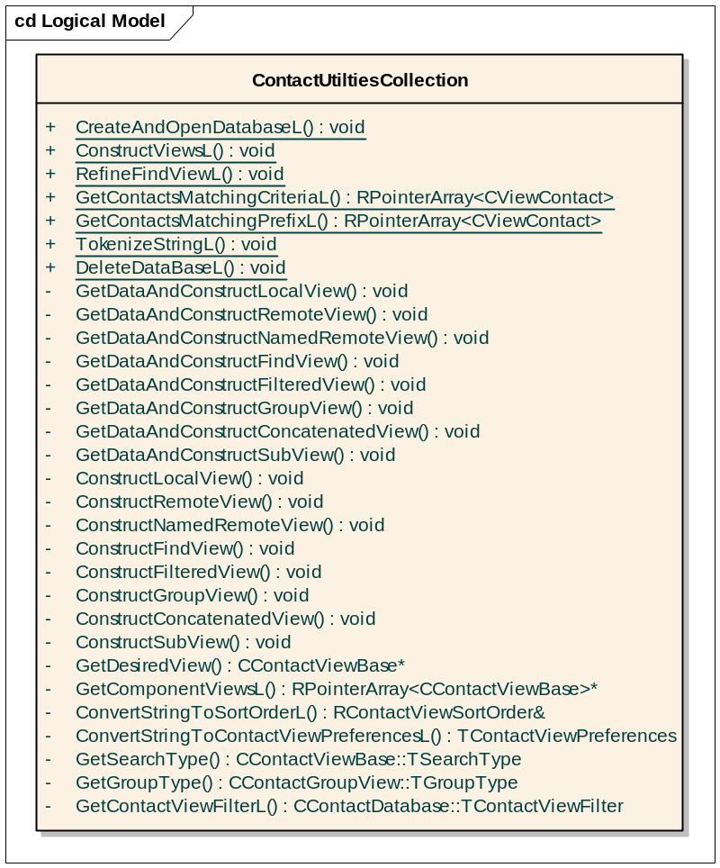
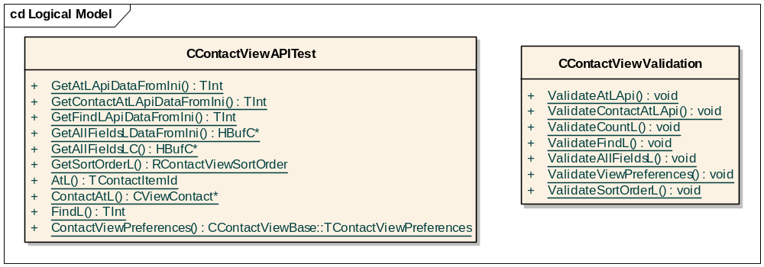
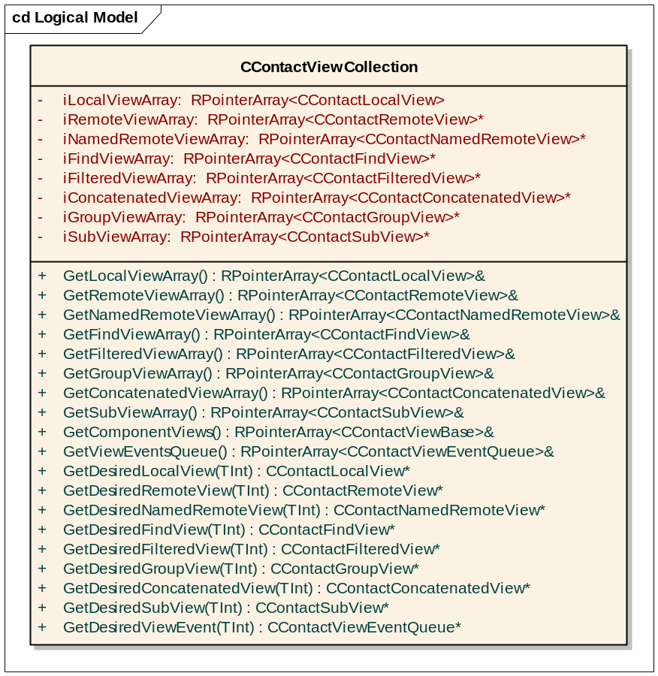

CTestContactViewConstructionStep

Overview
This test step will support test cases which involve testing of contacts views construction and validate the newly constructed views. The following test cases will be covered here.
- APPENG-CONTACTS-VIEWS -I-0002-HP Construct views with different Sort Order.
- APPENG-CONTACTS-VIEWS -I-0003-HP Construct views with different view preferences.
- APPENG-CONTACTS-VIEWS -I-0039-HP Construct view, specify user defined sort plug-in
- APPENG-CONTACTS-VIEWS -I-0040-HP Construct view, use default sort plug-in
- APPENG-CONTACTS-VIEWS -I-0041-HP Construct view, specify empty descriptor as sort plug-in
- APPENG-CONTACTS-VIEWS -I-0042-HP Construct view, while default sort plug-in not available.
- APPENG-CONTACTS-VIEWS -I-0031-HP Simulate syncml operations thro contacts import feature and try to construct
contact views at the same time.
- APPENG-CONTACTS-VIEWS -I-0014-HP Construct Find View under OOM conditions.
- APPENG-CONTACTS-VIEWS -I-0019-HP Construct Filtered View under OOM conditions.
- APPENG-CONTACTS-VIEWS -I-0024-HP Construct Group View under OOM conditions.
- APPENG-CONTACTS-VIEWS -I-0028-HP Construct Sub View OOM conditions.
- APPENG-CONTACTS-VIEWS -I-0032-HP Construct contact views under low disk conditions.
- APPENG-CONTACTS-VIEWS -I-0033-HP Construct contact view operations with media not in place.
- APPENG-CONTACTS-VIEWS -I-0037-HP Construct contact views with huge amount of contacts.
- APPENG-CONTACTS-VIEWS -I-0038-HP Construct contact views during with backup and restore.

UML Diagram
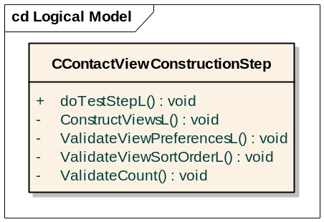

Test Module Behaviour
This test step is dedicated to test the view construction feature. It constructs the desired views based on the view construction criteria specified in the config section of the ini file. Once the views are successfully constructed, they are tested for correctness i.e. the view preference, sort order, order of contact view items etc. are compared against the expected values, specified in the config data section of the ini file.
The common view construction criteria are
- Type of View to be constructed
- Underlying view to be used
- View sort order
- View preferences
- Type of contacts to be included in the view
- Sort Plugin to be used
- Valid boundary conditions in case of Sub view
- Search string in case of Find view
- Collection of views to be used in case of Concatenated view

As mentioned above the utility function ContactUtilitiesCollection::ConstructViewsL is used for this purpose. Once the desired views are constructed, the corresponding view observers are validated for the desired view construction related events like view ready, unavailable, sort error, server error. This test step also supports testing of the contact view construction under constraints like disk full, disk not ready, OOM etc..
Functions like
- ContactUtilitiesCollection::ConstructViewsUnderOOM
- ContactUtilitiesCollection::ConstructViewsWithDiskFull etc..
are available for this purpose, The results of view construction under such circumstances are validated against the expected errors mentioned in the ini file.

Configuration file sample section
[viewconstruction_1]
createdatabase=TRUE
deletedatabase=TRUE
databasename=C:ViewContacts.cdb
sourceimportfile=C:\cntpreftest\testdata\vcards\vcard01.vcf
listofviews=localview_1, subview_1

[localview_1]
viewtype=localview
localviewpreferences = EContactsOnly, EUnSortedAtBeginning, EUnSortedAtEnd
localviewsortoder = firstname, lastname, middlename
expectedlocalviewcount=100
localsortpluginname = application.vnd.symbian.com/contacts-reverse-sort

[subview_1]
viewtype=subview
lowerboundary= >a
upperboundary= <z
expectedviewcount=20

Sequence Diagram

Below is the interaction diagram for the test step client CContactViewConstrustionStep with the ContactUtiltiesCollection Class. Here, we have taken an example of constructing two different types of views like local view and find view and checking the count of the local view.
Here is the detailed explanation of how we construct a local view and validate the count of it.
To construct the desired view, the required viewtype and the database name is passed in the ini file Say, we want to construct the local view, then the view type that is passed in the ini file is localview. The test step takes the input and calls the function CreateAndOpenDataBaseL of ContactUtilitiesCollection which will return a pointer of type CContactDatabase to the test step client.
To Construct the view, the test step client calls the ConstructViewsL() function of ContactUtiltiesCollection by passing the CContactDatabase pointer and a reference to the CContactViewCollection Class. Say, the view type that we have passed is local view, then the ConstructViewsL() function calls the corresponding get function of local view i.e it calls GetDataAndConstructLocalView which reads the data required for the construction of the local view from the ini file and calls the method constructLocalViewL() which will really construct the local view. The constructed view and the vieweventobserver will be appended to their corresponding arrays of CContactViewCollection. Ie. The local view pointers are appended to localViewArray which is of type RPointerArray<CContactLocalView>.
Once the view is constructed, the function returns back to the test step client where the client tries to get the desired view for validation. Again, the type of the view and the index is taken from the ini file and passed to the method GetDesiredView() of CContactViewCollection and in turn it returns the desired view.
To Validate the view, we check the count, view preferences and sort order are retrieved as expected by calling the corresponding validate function from the CContactViewValidation Class. Say, for eg. If we want to validate the count, then we call the function ValidateCountL() of CContactViewValidation by passing the desired view and in turn get the Boolean variable to check if the result is successful or not.

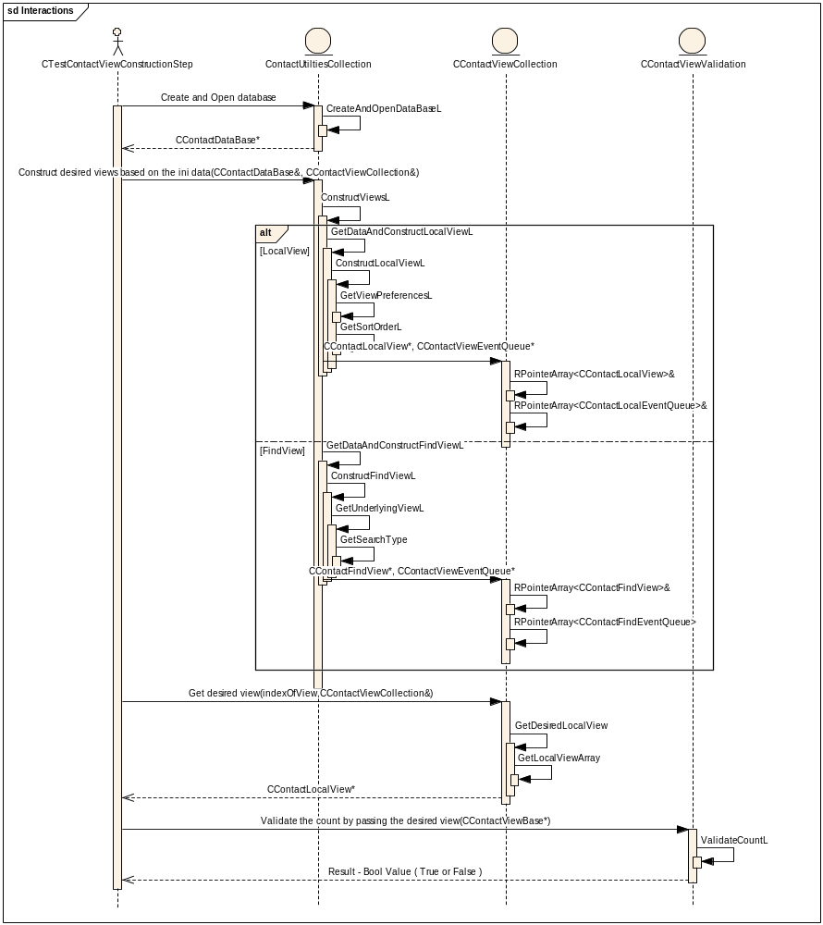

CTestContactViewAccessStep
This test step will support test cases which involve testing of contacts view access apis. The following test cases will be covered here.

Overview
- APPENG-CONTACTS-VIEWS -I-0057-HP Construct any view and retrieve the contact view items matching the
search criteria string in all contact fields of all contacts in the view.
- APPENG-CONTACTS-VIEWS -I-0058-HP Construct any view and retrieve the contacts matching the search string
in the prefix of all contact fields of all contacts in the view.
- APPENG-CONTACTS-VIEWS -I-0059-HP Construct any view and retrieve the contacts matching the prefix where
the search string does not match any contact field of any contact in the view.
- APPENG-CONTACTS-VIEWS -I-0060-HP Construct any view and retrieve the contacts matching the prefix where
the search string does not match the prefix of any contact field of any contact
in the view.
- APPENG-CONTACTS-VIEWS -I-0044-HP Pass valid index and extract all the field content of a contact item in
the view.
- APPENG-CONTACTS-VIEWS -I-0045-HP Pass invalid index and try to extract all the field content in the contact
item in the view.
- APPENG-CONTACTS-VIEWS -I-0046-HP Create a sub view and find all the fields of the contact item in the view.
- APPENG-CONTACTS-VIEWS -I-0047-HP Create any view and retrieve the contact item id present in the particular
index of the view.
- APPENG-CONTACTS-VIEWS -I-0048-HP Create any view and try to retrieve the contact item id, pass invalid
index.
- APPENG-CONTACTS-VIEWS -I-0049-HP Create any view and retrieve the contact item present in the particular
index of the view.
- APPENG-CONTACTS-VIEWS -I-0050-HP Create any view and try to retrieve the contact item, pass invalid index.
- APPENG-CONTACTS-VIEWS -I-0051-HP Create any view, try to retrieve the number of contact items present in
the view.
- APPENG-CONTACTS-VIEWS -I-0052-HP Pass a valid contact item Id and find the index of the contact item id in
the view.
- APPENG-CONTACTS-VIEWS -I-0053-HP Pass invalid contact item Id and try to find the index of the contact
item id in the view.
- APPENG-CONTACTS-VIEWS -I-0060-HP Invoke Asynchronous Sort in the contacts database and further try to
perform Contact view operations like search for contact items, contact
view count, retrieve contact info from the view.
- APPENG-CONTACTS-VIEWS -I-0061-HP Construct any view where there are no contacts for the preferences
specified during the view construction.
- APPENG-CONTACTS-VIEWS -I-0009-HP Refine Search criteria in a find view based on local view
- APPENG-CONTACTS-VIEWS -I-00012-HP Refine Search criteria in a find view based on a remote view
- APPENG-CONTACTS-VIEWS -I-0053-HP Refine the find view criteria with same search string that was used during
View Construction
- APPENG-CONTACTS-VIEWS -I-0054-HP Refine the find view criteria with entirely new search string

UML Diagram

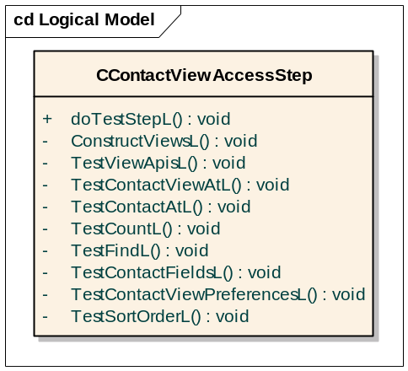

Test Module Behaviour
This test module will perform the tests like
- retrieving the content all the fields of the contact item in the view,
- retrieving the contact item in the view by specifying the contact id or the index of the contact item in the view
- retrieving the contact item id, by specifying the index of the contact item in the view.
- testing the impact of contact view access when the view is not ready to use,
- searching for a specific string or array of string in all the contact item fields or only the prefix of all contact item fields of all contacts in the view etc…
In general, it supports testing of all contact view access apis. During testing, the apis are supplied with both valid and invalid inputs. The results are validated against the expected results specified in the data section of ini file or the expected error code specified in the script file.The desired views are constructed using the ContactUtilitiesCollection::ConstructViewsL().

Below is the sequence diagram which depicts the interaction of test step client CTestContactViewAccessStep with CContactUtilitiesCollection Class. This is a sample which explains the interaction of few API’s like count, contactat and AllFieldsLC(). Here the construction of the views is not shown in detail as the previous sequence diagram describes in detail.

The API that is to be tested is passed in the ini file, Say if the ContactAtL() API is to be tested, then the type of the view and the testContactAtLApi variable is set to true in the ini file. The test step client reads the data from the ini file and calls the corresponding test functions. Here, We will look in detail of TestContactAtL API interaction…

Based on the view type specified in the ini file, the desired view is fetched from the CContactViewCollection Class and the TestContactAtL() function of CContactViewTest Class is called. This in turn calls the method GetContactAtLDataFromIni() which reads the data required for testing of the API. The API is called and the desired Contact is stored in the variable and it is passed to the ValidateContactAtL() method of Class CContactViewValidation. The ValidateContactAtL() API validates the desired contact with the expected result retrieved from the ini file and returns the Boolean variable to the test step client indicating the success or failure.
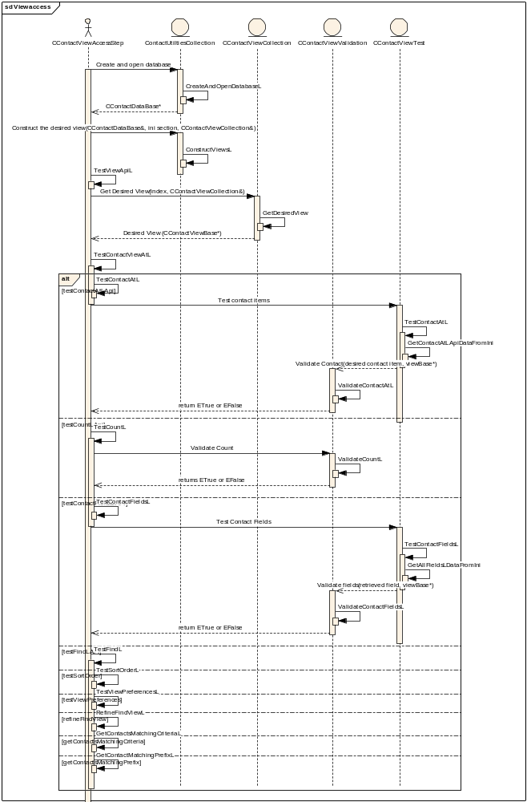

Configuration file sample section
[viewaccess_1]
createdatabase=TRUE
deletedatabase=TRUE
databasename=C:ViewContacts.cdb
sourceimportfile=C:\cntpreftest\testdata\vcards\vcard01.vcf
listofviews=localview

[localview]
viewtype=localview
localviewpreferences=EContactsOnly,EUnSortedAtBeginning,EUnSortedAtEnd
localviewsortorder =firstname,lastname,middlename
expectedlocalviewcount=100
viewaccesslisting = find_1,matchstring_1

[find_1]
testfindindex=10000

[matchstring_1]
desiredmatchstring=summer
expectedmatchingcontacts=10

CTestContactViewCRUDStep

Overview
This test step will construct the desired contact view and perform various crud operations in the contact database. Later it validates the constructed views for correct updating. The following testcases will be implemented here,

- APPENG-CONTACTS-VIEWS -I-0001-HP Construct views and carry out CRUD operations
- APPENG-CONTACTS-VIEWS -I-0004-HP Construct local view and carry out CRUD operations
- APPENG-CONTACTS-VIEWS -I-0005-HP Construct remote view and carry out CRUD operations
- APPENG-CONTACTS-VIEWS -I-0006-HP Construct named remote view and carry out CRUD operations
- APPENG-CONTACTS-VIEWS -I-0008-HP Construct find view over a local view and carry out CRUD operations
- APPENG-CONTACTS-VIEWS -I-0011-HP Construct find view over a remote view and carry out CRUD operations
- APPENG-CONTACTS-VIEWS -I-0015-HP Construct filtered view over a local view and carry out CRUD operations
- APPENG-CONTACTS-VIEWS -I-0017-HP Construct filtered view over a remote view and carry out CRUD operations
- APPENG-CONTACTS-VIEWS -I-0020-HP Construct group view over a local view and carry out CRUD operations
- APPENG-CONTACTS-VIEWS -I-0022-HP Construct group view over a remote view and carry out CRUD operations
- APPENG-CONTACTS-VIEWS -I-0025-HP Construct sub view over a local view and carry out CRUD operations
- APPENG-CONTACTS-VIEWS -I-0027-HP Construct sub view over a remote view and carry out CRUD operations
- APPENG-CONTACTS-VIEWS -I-0030-HP Construct concatenated view and carry out CRUD operations
- APPENG-CONTACTS-VIEWS -I-0038-HP Construct multiple views over a local view and carry out CRUD operations
- APPENG-CONTACTS-VIEWS -I-0039-HP Construct multiple views built over a remote view and carry out CRUD operations

Class Diagram

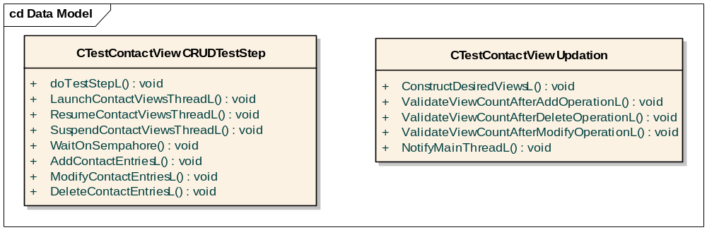

Sequence Diagram
A sample sequence diagram which depicts
- Starting of Contact views thread (A thread which has multiple contact views).
- enabling and disabling the view thread from the main thread.
- Addition of contact entries in the main thread.
- Validation of View count in the contact views thread.
is given below. The process is similar for updating and deletion of contact entries.

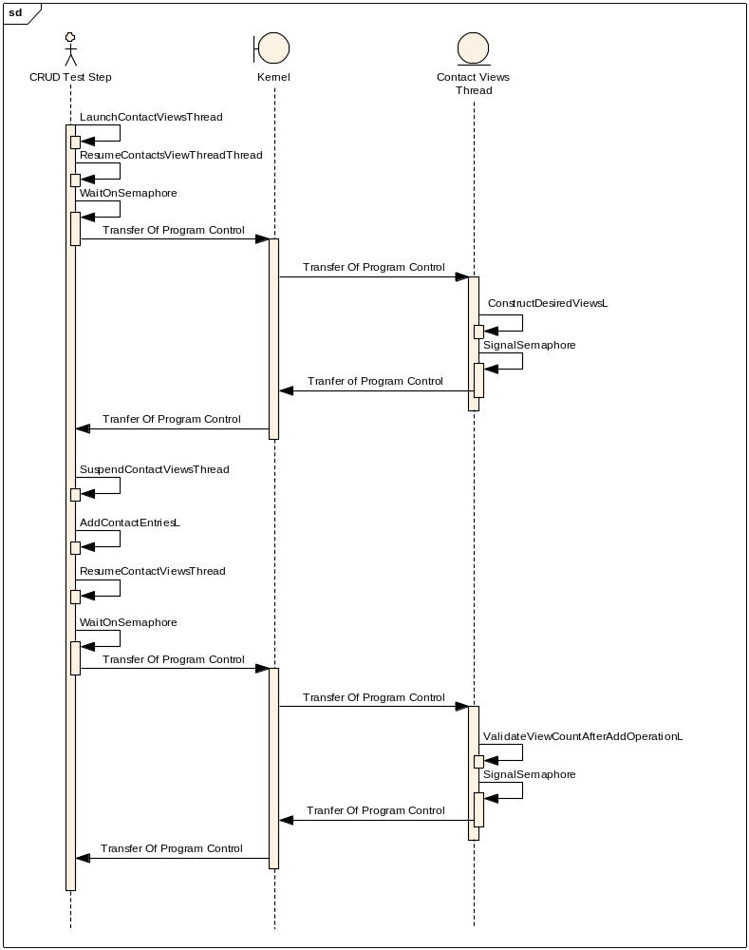

Test Module Behaviour
This test module will construct the desired contact views in a separate thread. Further in the main thread, contacts are added, modified and deleted in the database. These contacts may or may not meet the view preferences i.e. the view criteria. After each database CRUD operations, the view count of the contact views in the separate thread is validated against the expected view count mentioned in the ini file.
In the separate thread, an object of type CTestContactViewUpdate is constructed. Using this object, the desired contact views are constructed. Validation functions available in CTestContactViewUpdate are used to validate the views item count after CRUD operations on the database in the main thread.

Configuration file sample section
[crud_1]
createdatabase=TRUE
deletedatabase=TRUE
databasename=C:ViewContacts.cdb
sourceimportfile=C:\cntpreftest\testdata\vcards\vcard01.vcf
listofviews=localview

[localview]
localview=TRUE
viewpreferences=EContactsOnly
viewsortorder=firstname, lastname,middlename
expectedviewcount=100
crudoperations=create_1,update_1,delete_1

[create_1]
addcontactimportfile= C:\cntpreftest\testdata\vcards\vcard02.vcf
expectedviewcountafteradd=110
[update_1]
updatecontactimportfile= C:\cntpreftest\testdata\vcards\vcard03.vcf
expectedviewcountafterupdate=120

[delete_1]
deletecontactimportfile= C:\cntpreftest\testdata\vcards\vcard04.vcf
expectedviewcountafterdelete=50

CTestContactUpdateUnderlyingViewStep

Overview
This test step supports testing the impact on dependant views when the underlying view is updated. There can be multiple views dependant on a single view.
The following test cases are covered here.
- APPENG-CONTACTS-VIEWS -I-0009-HP Update find view based on a local view, indirectly
- APPENG-CONTACTS-VIEWS -I-0013-HP Update find view based on remote view indirectly
- APPENG-CONTACTS-VIEWS -I-0016-HP Update Filtered view based on a local view, indirectly
- APPENG-CONTACTS-VIEWS -I-0018-HP Update find view based on remote view indirectly
- APPENG-CONTACTS-VIEWS -I-0021-HP Update Group view based on a local view, indirectly
- APPENG-CONTACTS-VIEWS -I-0023-HP Update Group view based on remote view indirectly
- APPENG-CONTACTS-VIEWS -I-0026-HP Update sub view based on a local view, indirectly
- APPENG-CONTACTS-VIEWS -I-0028-HP Update sub view based on remote view indirectly

Class Diagram

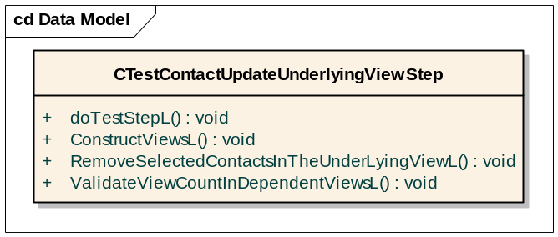

Test Module Behaviour
This test step will construct the desired dependant views like find view, filtered view, sub view, concatenated view or group view over existing local view or remote view or named remote view. Further the underlying local view or remote view or named remote view updated i.e. some of the contact view items in the underlying view are removed. The view count of the dependant view is validated against the expected view count specified in the ini file.

Configuration file sample section
[underlyingviewupdate _1]
createdatabase=TRUE
deletedatabase=TRUE
databasename=C:ViewContacts.cdb
sourceimportfile=C:\cntpreftest\testdata\vcards\vcard01.vcf
listofviews =localview

[localview]
localview=TRUE
viewpreferences=EContactsOnly
viewsortorder=firstname, lastname,middlename
expectedviewcount=100
removecontacts=TRUE
index=10,15,20
expectedviewcountafterremoval=97

CTestContactViewNotificationStep

Overview
This test step will perform various contact view related operations like creating the view, accessing view elements, updating the underlying view, performing add modify and delete of contact information in the contact database and validate the notification information i.e. number of notifications, type of notification and other notification related data received against the expected notifications in the ini file. It would be very difficult to validate the expected notification information in each and every test step. Hence all the relevant testcases which require notification information validation will be covered in this test step.

Class Diagram
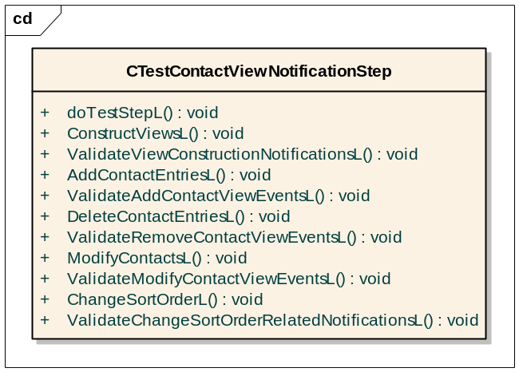

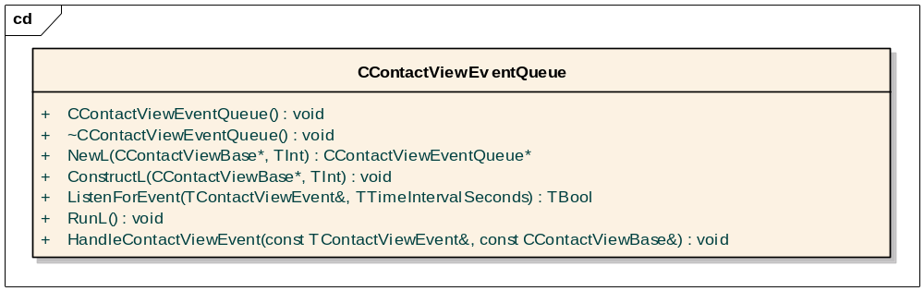

Test Module Behaviour
This test module will construct all the desired views using the utility function ContactUtilitiesCollection::ConstructViewsL(). Further various contact database and view related operations are performed in the test step. At the end of each operation, notifications received by the contact view observers are grouped under different categories based on the view event types. All possible contact view notifications types are - view unavailable, view ready, view sort error, view server error, indexing error, sort order changed, contact item added, contact item removed & group changed. A similar expected contact view events in each category of contact view notifications is listed in the ini file. On comparison of both these lists, the contact view notifications are validated.
The contact view notifications are captured using CContactViewEventQueue objects . CContactViewEventQueue objects are basically view observers, they are allocated during view construction and further appended to CContactViewCollection. Using these view observers, we can listen to contact view events and validate the notifications received against the expected notifications.
The following example illustrates the usage of CContactViewEventQueue object, which will be extensively used in the notification test step. All contact view notification validation tests are covered in the Notification Test step, mainly to avoid code duplication and scattering of test code.
CContactViewEventQueue* viewEventQueue = NULL;
viewEventQueue = CContactViewEventQueue::NewL();
contactsView = CContactLocalView::NewL(*viewEventQueue, db, viewSortOrder, EContactsOnly);
TContactViewEvent event;
TEST(viewEventQueue ->ListenForEvent(10, event));
TEST(event.iEventType == TContactViewEvent::EReady);
// Perform Contact Add Operation on the database
TEST(viewEventQueue ->ListenForEvent(10, event));
TEST(event.iEventType == TContactViewEvent::EContactAdd);

Configuration file sample section
[viewnotification_1]
createdatabase=TRUE
deletedatabase=TRUE
databasename=C:ViewContacts.cdb
sourceimportfile=C:\cntpreftest\testdata\vcards\vcard01.vcf
listofviews=localview

[localview]
localview=TRUE
viewpreferences=EContactsOnly
viewsortorder=firstname, lastname,middlename
expectedviewcount=100
totalnumberofaddcontactsviewnotifications=10
crudoperations=create_1,

[create_1]
addcontactimportfile= C:\cntpreftest\testdata\vcards\vcard02.vcf
expectedviewcountafteradd=110

Environment Considerations
These tests are to be run on a PC running an emulator and a H4 development board. The tests are intended to be run without user intervention using Epoc (textshell/techview) for an emulator and using Epoc (techview) for the H4 board. The test solution will run on EKA2 and will have full compliance with the existing tests. The test will use Symbian OS version 9.4 (Oghma release
Test harness will require a new data configuration file(.ini) to store all the data necessary for the test cases, the file will be stored in the testdata folder. Most of the test cases do not require the path of the database file. Few of the tests like back up and restore requires the path of the file. In order to achieve it and address the configurabilty for Oghma, there will be multiple ini files defined for the test suite.
- TestContactViewSuite.ini. – An ini file can have any number of sections but the section name should not be repeated again.
- TestContactViewSuite.script

Automation Requirements
The test cases defined in this design will require All -TCB security capabilities to run.
The test cases will be implemented using the TEF testing framework, the TEF client will be used to run the tests. To execute a test you need to execute the following command:
$TESTEXECUTEPATH$\Testexecute.exe $TESTSCRIPTSPATH$\$TESTSCRIPTNAME$
For example:
M:\epoc32\RELEASE\WINSCW\UDEB\testexecute.exe c:\ContactViews\scripts\ TestContactViewSuite.script
The above command can be used to automate TEF tests when run on the emulator. Also for emulator automated testing just in time debugging needs to be disabled (add “JustInTime none” to epoc.ini).
For hardware testing, XML files need to be created specifying the test harness to be used, the scripts required to execute the test and the configuration/data files required by the test cases. An XML file will be created for each new test module:
- TestContactViewSuite.xml
The existing test harness to be used by the new test cases is located in the following perforce location:
//EPOC/master/common/generic/app-engines/Cntmodel/tsrc/Integration/TestContactViewSuite/...

Sample XML File
<testExecuteTest>
<name>TestContactViewSuite</name>
<timeout>500</timeout>
<testScripts>
<script>
<hostPath>\epoc32\data\c\contactview\scripts\TestContactViewSuite.script</hostPath>
<devicePath>c:\contactview\scripts\TestContactViewSuite.script</devicePath>
</script>
</testScripts>
<testServers>
<server> TestContactViewSuite </server>
</testServers>
<dependencies>
<data> <hostPath>\epoc32\data\c\contactview\data\TestContactViewSuite.ini</hostPath>
<devicePath>c:\contactview\data\TestContactViewSuite.ini</devicePath>
</data>
</dependencies>
</testExecuteTest>

Further Information

People
Role | Person / People
Reviewers | John Owen, Tom Bassett, Lucian Piros, James Clarke
Contributors | Anitha, Krishna

References
No. | Document Reference | Version | Description
[R1] | //EPOC/development/Master/common/testtools/TestExecute/Documentation/SGL.PR0088.301_TEF_FunctionalDescription.doc | 1.7 | Test Execute Framework Functional Description.
[R2] | SGL.GT0323.405 PIM Contacts Model View Operations Test Specification v0.3.doc | 0.2 | This document describes the test cases that are designed for PREQ 1187.
[R3] | SGL.GT0323.212 Contact View Architecture Porting Design - v0.2.doc | 0.2 | This document describes the new design architecture and implementation details of contact views.

Document History
Date | Version | Status | Author | Description
14-02-2007 | 1.0 | Issued | Krishna | Changed the document status from draft to issued state.
09-02-2007 | 0.4 | Draft | Krishna, Anitha | Implemented additional review comments
06-02-2007 | 0.3 | Draft | Krishna, Anitha | Updated the test diagram with test design and more explanation
24-01-2007 | 0.2 | Draft | Anitha, Krishna | Incorporated review comments of Tom, John & Lucian.
05-01-2007 | 0.1 | Draft | Krishna , Anitha | First draft based on SGL.GT0323.405 PIM Contacts Model View Operations Test Specification v0.2.doc

